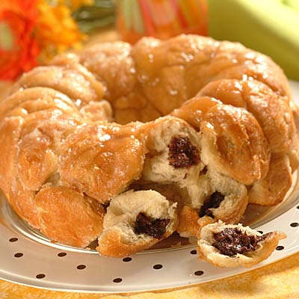 Monkey Bread Chocolate Filled

Ingredients
- 18 frozen white dinner rolls,
- 1 1/2 cups (9 oz.) Semi-Sweet Chocolate _________________
- 1/4 cup (1/2 stick) butter, melted _________________
- 1/2 cup packed light brown sugar _________________
- 1/2 cup butterscotch sauce (optional) _________________
- 1/4 cup NESTLÉ NESQUIK Chocolate Flavor Syrup, (optional)
Directions PREHEAT oven to 350° F
GREASE 12-inch Bundt pan. CUT each roll in half. Press each half into 3-inch circle. Place 10 or 11 morsels in center of dough circle, shaping dough into a ball around morsels. Pinch dough to seal. Repeat with remaining dough and morsels. Dip each in melted butter and roll in sugar. Arrange dough balls in prepared pan. Cover; let rise in warm place for 20 minutes.
BAKE for 30 minutes or until golden brown. Cool in pan on wire rack for 20 minutes. Loosen sides and invert onto serving platter.

